Save The Date!

Dear Rockingham Families,

Mark your calendars! The fun and excitement of a Scholastic Book Fair is coming to our school! Students and families will have the option of attending the Scholastic Book Fair in-person at the school library and/or virtually.

- Virtual Book Fair: (November 21- December 5)
  - https://virtualbookfairs.scholastic.ca/pages/5180446
  - Link to Virtual Book Fair will also be available on the school website.
  - Shop any time! Your Virtual Fair is open 24 hours, beginning at midnight November 21st!
  - No shipping fees! Orders are sent directly to our school.

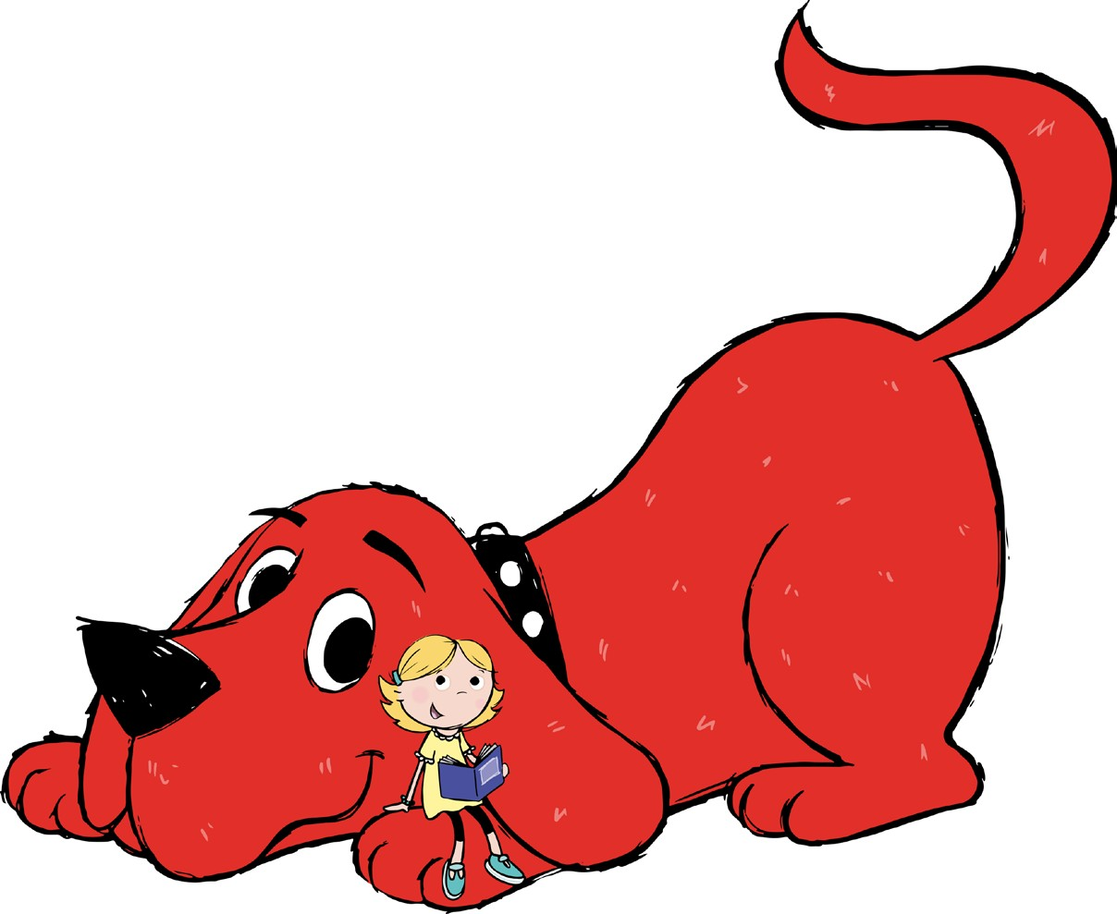
- In-Person: (November 24- December 1)
  - Location: Rockingham Library.
  - Will be open during Parent-Teacher Interviews.
  - All classes will be shopping at the Book Fair during school hours.
  - Please enclose all money in an envelope or Ziplock bag.

Happy Reading!

